System Design Document
Unified Service Scheduler
Technology Stack: ASP.NET Core Web API, C#, .NET 8, SQL Server, NPoco, T-SQL Stored Procedures, Swagger/OpenAPI
1. Project Overview
The Unified Service Scheduler is a backend application designed to help customers book vehicle servicing appointments at dealerships.
The system identifies suitable service bays and technicians based on the selected dealership, service type, requested date and time, and existing bookings. It prevents a service bay or technician from being assigned to overlapping appointments.
The application provides APIs for searching dealerships, checking service availability, and booking appointments. Business validations are implemented in the service layer and database stored procedures, while SQL Server maintains the appointment and resource records.
Key objectives
- Allow users to search dealerships using filters and pagination.
- Determine whether a service bay and qualified technician are available for the requested duration.
- Store appointment details with the associated customer, vehicle, dealership, bay, and technician.
- Prevent conflicting appointments when multiple booking requests arrive concurrently.
- Maintain a clear separation between API handling, business logic, and database access.
2. High-Level Architecture
The application follows a layered architecture. The ASP.NET Core application communicates with SQL Server through NPoco, using stored procedures for database operations.
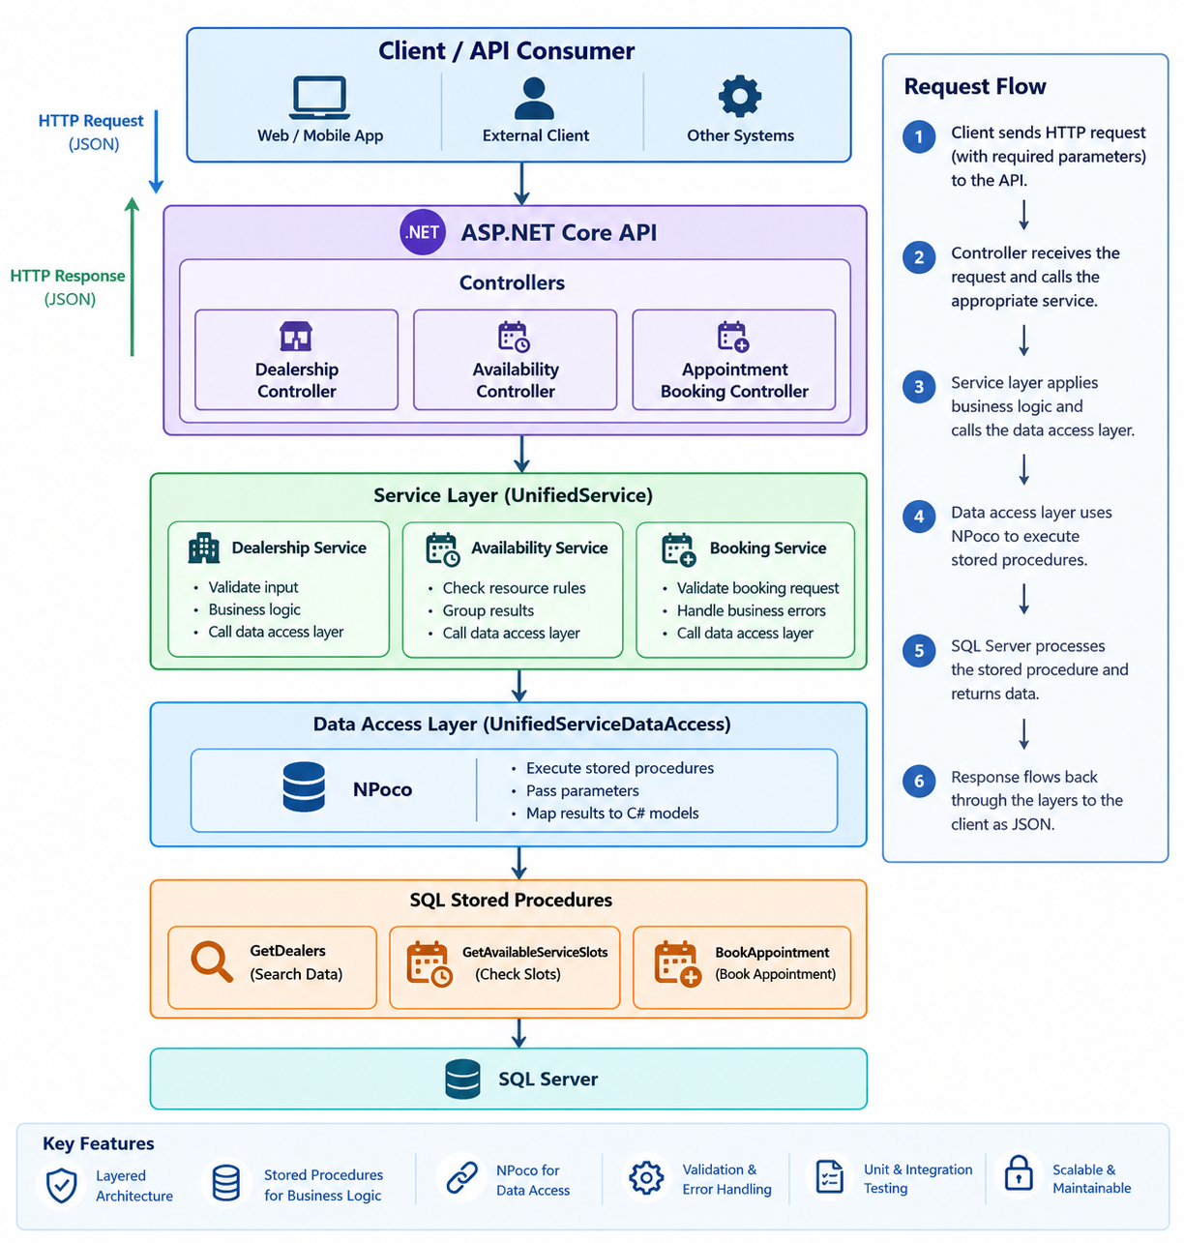
The diagram represents the logical flow. The three API operations are exposed by the current controller rather than necessarily being separate controller classes.
2.1 Presentation layer — Controllers
The controller receives HTTP requests, binds query parameters or JSON request bodies, calls the service layer, and returns HTTP responses.
Responsibilities:
- Accept and validate request formats.
- Invoke the appropriate service method.
- Return successful results.
- Convert known application exceptions into appropriate HTTP responses.
- Return a generic internal-server-error response for unexpected exceptions.
The controller does not directly execute SQL queries.
2.2 Business layer — UnifiedService
The service layer contains the application-level business logic.
Responsibilities include:
- Rejecting invalid dealer IDs.
- Validating required appointment request fields.
- Grouping availability results by dealer.
- Logging relevant operations and failures.
- Translating selected SQL business errors into AppointmentBookingException.
- Calling the data-access layer to retrieve data or create appointments.
For example, when the dealer ID is zero or negative, the availability method rejects the request before querying the database.
2.3 Data-access layer — UnifiedServiceDataAccess
The data-access layer implements IUnifiesServiceDataAccess and uses NPoco's IDatabase abstraction.
Responsibilities:
- Execute SQL Server stored procedures.
- Pass procedure parameters.
- Map returned records to C# models.
- Return dealership, availability, and appointment results to the service layer.
Using an interface allows the service layer to be unit-tested with mocks without connecting to SQL Server.
2.4 Database layer — SQL Server
SQL Server stores the business entities and enforces the relationships between customers, vehicles, dealerships, services, technicians, bays, and appointments.
Stored procedures contain the main database operations and booking validations. Appointment conflicts must be checked and the booking inserted within the same appropriately protected transaction.
3. API Design
The current controller route is:
/api/UnifiedServiceScheduler
The following endpoints reflect the controller implementation discussed for the project.
API | HTTP method | Purpose
/api/UnifiedServiceScheduler/getDealerDetails | POST | Search and retrieve dealership information
/api/UnifiedServiceScheduler/getAvailableSlots | GET | Retrieve eligible bays and technicians, with availability flags when a requested time is supplied
/api/UnifiedServiceScheduler/bookAppointment | POST | Validate and create an appointment
3.1 Search dealerships
Endpoint: POST /api/UnifiedServiceScheduler/getDealerDetails
Purpose: Retrieve dealerships using optional search criteria and pagination.
Example request:
{
"limit": 10,
"offSet": 0,
"dealerName": "ABC",
"city": "Mysuru",
"serviceType": "Full Service",
"sortOrder": "ASC"
}
Processing flow:
- The controller receives the DealerSearch request.
- The service calls GetDealerDetail.
- The data-access layer executes dbo.GetDealers.
- SQL Server applies the filters and pagination and returns the dealer records and total count.
- The application constructs a response containing the dealer details and paging metadata.
The response includes the dealership list, total matching records, requested page offset and limit, and number of records returned.
Achievement: Clients can search dealerships without retrieving the entire dealership catalog.
Design improvement: Because this operation retrieves data rather than changing it, a GET endpoint would be more conventional REST design. The existing POST endpoint can be retained for compatibility or changed as part of an API design revision.
3.2 Check service availability
Endpoint: GET /api/UnifiedServiceScheduler/getAvailableSlots
Purpose: Retrieve service bays and qualified technicians for a dealership and, when supplied, evaluate their availability for a requested service time.
Example request:
GET /api/UnifiedServiceScheduler/getAvailableSlots?dealerId=1&serviceName=Full%20Service&startTime=2026-11-02T13:00:00
Processing flow:
- The controller receives the dealer ID, optional service name, and optional start time.
- The service rejects invalid dealer IDs.
- The data-access layer executes dbo.GetAvailableServiceSlots.
- SQL Server checks the dealership, service, bay capabilities, technician skills, availability windows, and conflicting appointments.
- The service groups the resulting rows by dealership.
- The controller returns the resulting records.
When the client provides only a dealer ID, the API can return eligible resources without evaluating a specific time. Availability flags are represented as nullable Boolean values so that “not evaluated” is distinct from “unavailable.”
The availability evaluation uses the following conditions:
- The bay must support the selected service.
- The technician must have the required skill.
- The requested interval must fit inside the resource's availability window.
- The resource must not have a conflicting, non-cancelled appointment.
For two time intervals, a conflict exists when:
ExistingStartTime < RequestedEndTime
AND ExistingEndTime > RequestedStartTime
This condition detects partial overlaps, complete overlaps, and appointments that start or finish inside another appointment. Appointments that merely touch at their boundaries do not overlap under this rule.
Achievement: The application can identify eligible resources and detect scheduling conflicts before attempting to create a booking.
Important distinction: Availability is a preliminary result. Another request can book the resource after availability is checked, so the booking procedure must revalidate availability during the actual booking transaction.
3.3 Book an appointment
Endpoint: POST /api/UnifiedServiceScheduler/bookAppointment
Purpose: Create a confirmed appointment for a user, vehicle, dealership, service, bay, technician, and requested start time.
Example request:
{
"userId": 1,
"vehicleId": 2,
"dealerId": 1,
"serviceName": "Full Service",
"bayId": 10,
"technicianId": 20,
"startTimeUtc": "2026-11-02T13:00:00"
}
Processing flow:
- The controller receives the booking request.
- The service validates the required IDs and service name.
- The data-access layer calls dbo.BookAppointment through NPoco.
- The stored procedure validates the user and vehicle relationship, dealership, service, bay capability, technician qualification, and resource availability.
- The stored procedure calculates the appointment end time from the service duration.
- It checks for conflicting appointments and inserts the appointment inside a protected transaction.
- The generated appointment ID is returned to the API client.
Example successful response:
{
"appointmentId": 1001
}
Achievement: Appointment creation and resource assignment are handled through one database operation, with validation performed close to the data.
Concurrency requirement: The validation, conflict checks, and insert must be protected by suitable transaction isolation or locking. The final database design should be tested with simultaneous requests to ensure that only one conflicting booking succeeds.
4. Database Design
The database is relational and uses primary keys and foreign keys to maintain relationships between business entities.
4.1 Core tables
Table | Responsibility
Users | Stores customer or user records
Vehicles | Stores vehicles associated with users
DealerCentres | Stores dealership information
Services | Stores service types and service duration
DealerServices | Associates dealerships with the services they offer
ServiceBays | Stores service bays belonging to dealerships
BayCapabilities | Maps service bays to supported services
BayAvailability | Stores bay availability windows
Technicians | Stores technicians and their dealership associations
TechnicianSkills | Maps technicians to the services they can perform
TechnicianAvailability | Stores technician availability windows
Appointments | Stores booked appointments and assigned resources
4.2 Main relationships
- A user can own multiple vehicles.
- A dealership can offer multiple services through DealerServices.
- A dealership can have multiple service bays and technicians.
- A service bay can support multiple service types through BayCapabilities.
- A technician can have multiple skills through TechnicianSkills.
- A booking associates a vehicle and user with a dealership, service, bay, and technician.
- Availability tables define when bays and technicians can be scheduled.
These relationships allow the system to determine not only whether a time is free, but also whether the requested service can be performed by the selected bay and technician.
4.3 Appointment integrity
The Appointments table is central to scheduling. It stores the resource assignments and appointment start and end times.
The database should enforce or validate:
- Valid foreign-key relationships.
- Correct appointment duration.
- Resource availability.
- No overlapping non-cancelled appointments for the same bay.
- No overlapping non-cancelled appointments for the same technician.
- Correct handling of cancelled appointments.
The schema should also include appropriate indexes for resource IDs, appointment start/end times, and other frequently queried fields.
5. Concurrency and Transaction Design
Concurrent booking is a critical system requirement.
Consider two clients submitting the same booking request at nearly the same time. If both requests check availability before either inserts an appointment, both may incorrectly conclude that the resource is free.
The intended booking flow is:
- Begin a database transaction with suitable isolation and locking.
- Validate the requested service and resources.
- Check the bay's availability window.
- Check the technician's availability window.
- Check for overlapping active appointments for both resources.
- Insert the appointment only if all checks pass.
- Commit the transaction; otherwise, roll it back.
The application should use a coordinated concurrency test that submits identical requests simultaneously and verifies the result against SQL Server.
Success criterion: Exactly one request succeeds when all requests target the same bay and technician for the same conflicting time interval. The remaining requests must be rejected, and no duplicate conflicting appointments should be persisted.
A successful test run is evidence of correct concurrency handling for the tested conditions; it is not a substitute for reviewing the transaction isolation, lock behavior, and database indexes.
6. Error Handling and Logging
The application uses AppointmentBookingException for application-level booking errors and logs operations using ILogger<UnifiedService>.
Expected handling includes:
- Invalid input: reject the request before unnecessary database work.
- Known business-rule violations: return an appropriate client error.
- Unexpected database or application failures: log the error and return a server error.
- Resource conflicts: reject the booking without inserting a conflicting appointment.
SQL exception numbers should not automatically determine the HTTP status code. The application should distinguish expected business-rule errors from infrastructure failures such as database timeouts or unavailable connections.
Detailed internal exception messages should not be exposed to API clients for unexpected server failures.
7. Technology Choices
Technology | Reason for use
ASP.NET Core Web API | Exposes HTTP endpoints for clients
C# / .NET 8 | Implements controller and service logic
SQL Server | Stores relational business and appointment data
NPoco | Executes database operations and maps query results
Stored procedures | Centralize data retrieval, validation, and booking operations
Swagger/OpenAPI | Supports API exploration and manual testing
xUnit and Moq | Support unit testing of application layers
ILogger<T> | Provides structured application logging
8. Testing Strategy
The system should be tested at multiple levels.
Unit tests
Test service-layer behavior independently of SQL Server, including:
- Invalid dealer IDs and booking requests.
- Availability grouping.
- Successful appointment ID propagation.
- Conversion of expected business errors.
- Propagation of unexpected exceptions.
Mock IUnifiesServiceDataAccess when testing UnifiedService.
Data-access tests
Mock NPoco's IDatabase to verify that methods invoke the expected operations and map returned values correctly.
These tests do not verify the actual stored procedures.
Integration tests
Run against a dedicated SQL Server test database to verify:
- Stored procedure behavior.
- Foreign-key and business-rule validation.
- Resource availability calculations.
- Appointment creation and cancellation behavior.
- Transaction rollback on failure.
- Concurrent booking protection.
API tests
Verify request binding, response formats, HTTP status codes, and error handling through the actual HTTP endpoints.
9. Security and Operational Considerations
The current project scope does not include a completed authentication and authorization implementation. User and vehicle validation inside the booking procedure does not, by itself, prove that the caller is authorized to act as that user.
For a production deployment, consider:
- Authentication and authorization for API consumers.
- Deriving the caller's identity from a trusted authentication mechanism rather than trusting a client-supplied UserId.
- Validating that a vehicle belongs to the authenticated user.
- Consistent UTC handling for appointment times.
- Configuration and secret management outside source control.
- Structured logs, request correlation IDs, and operational monitoring.
- Rate limiting and appropriate API error responses.
10. Achievements and Expected Outcomes
The design and implementation establish a foundation for:
- Unified dealership discovery: Clients can search and filter dealerships with pagination.
- Resource-aware scheduling: Bay capabilities, technician skills, and availability windows are considered when identifying candidate resources.
- Conflict detection: Appointment intervals are compared against existing non-cancelled bookings.
- Centralized booking validation: The stored procedure is responsible for final database-side validation and insertion.
- Layer separation: Controllers, services, data access, and SQL operations have distinct responsibilities.
- Testability: Interface-based dependencies support isolated unit tests.
- Consistent error handling: Known booking failures can be translated into application-specific errors and HTTP responses.
These outcomes should be described as verified achievements only after the corresponding implementation and tests have been completed.
11. Future Enhancements
Potential improvements include:
- Replace the dealership-search POST endpoint with a GET endpoint if compatible with the client contract.
- Add authentication and user authorization.
- Add a dedicated endpoint for retrieving available time slots rather than requiring clients to interpret resource combinations.
- Improve database indexing for availability and overlap queries.
- Add automated integration and concurrency tests to the CI pipeline.
- Add idempotency support if clients need safe retries after network failures.
- Add caching for relatively static dealership and service catalog data, while keeping booking availability checks authoritative.
- Add metrics and monitoring for booking failures, SQL latency, and resource contention.
12. Conclusion
The Unified Service Scheduler is a layered .NET Web API backed by a relational SQL Server database. It supports dealership discovery, service-resource availability evaluation, and appointment booking. Its central design requirement is to ensure that a service bay and qualified technician are assigned only when they are eligible and available for the complete requested duration.
The key correctness requirement is that final availability validation and appointment insertion are protected against concurrent requests at the database level. Combined with appropriate API validation, structured logging, and automated testing, this design provides a foundation for a reliable vehicle service scheduling system.

